GPS
Vehicle
Tracker

User Guide

V7.1

HS-300V

Contents
1. Product Overview - 3 -
2. For Your Safety - 3 -
3. HS-300V Characteristics - 4 -
4. Getting Started - 5 -
4.1 Hardware and Accessories - 5 -
4.2 View - 5 -
4.3 Functional Parts - 5 -
4.4 Connecting and Installation - 7 -
5. Change Password - 7 -
6. Time Zone - 8 -
7. Track - 8 -
7.1 Track by SMS - 8 -
7.2 Track by Calling - 9 -
7.3 Track by Preset Interval - 9 -
7.4 Google Earth and Google Map - 9 -
7.5 Track by MS01/MS02 - 10 -
7.6 Track by GPRS (o Protocol) between Server and Tracker - 10 -
7.6.1 Set Tracker’s GPRS ID - 10 -
7.6.2 Set APN - 11 -
7.6.3 Set IP and Port - 11 -
7.6.4 Set DNS Server IP (optional) - 11 -
7.6.5 Enable GPRS Tracking - 11 -
7.6.6 Set GPRS Interval - 11 -
7.7 Track by GpsGate - 12 -
8. Authorization - 12 -
9. Application Examples for Inputs - 12 -
9.1 SOS Button Connection - 12 -
9.2 Detecting Lock Status of Car’s Door or Trunk (Car Boot). - 13 -
9.3 Connecting with Switch Sensors - 13 -
9.4 Ignition Detection - 13 -
9.5 Analog Input (AD1 and AD2) - 13 -
10. Speeding Alarm - 14 -
11. Movement/Geo-fence - 14 -
11.1 Movement Alarm - 15 -
11.2 Geo-fence Alarm - 15 -
12. Track by Distance - 16 -
13. Listening-in (Optional) - 16 -
14. Set Sensitivity of Tremble Sensor - 16 -
15. Output Control - 16 -
15.1 Output Control (Immediate) - 16 -
15.2 Output Control (Conditional) - 17 -
15.3 Application Examples for Outputs - 17 -
15.3.1 Engine Cut - 17 -
15.3.2 Connecting with Car Alarm - 17 -
16. Heading Change Report - 18 -
17. Heartbeat - 18 -
18. Track Log - 18 -
18.1 Log by Interval - 18 -
18.2 Auto Log when no GPRS - 19 -
18.3 Format Buffer - 19 -
19. Power Down - 19 -
20. Get IMEI - 20 -
21. Initialization - 20 -
22. Password Initialization - 20 -
23. Parameter Editor - 20 -
24. Copyright and Disclaimer - 21 -
Annex 1. SMS Command List - 21 -
Annex 2. Troubleshooting - 27 -
Contacts - 29 -

1. Product Overview

HS-300V is a GPS/GPRS based tracking device, specially developed and designed for vehicle real-time tracking and fleet management.

HS-300V has an inbuilt GPS module to obtain accurate position data. This device utilizes its GSM capability to send position data to a specified mobile phone or server base for tracking and fleet management.

With internal memory, HS-300V can store GPS coordinates when there is no GPRS connection, or at a specified interval requested by the user.

One optional feature of HS-300V is that a microphone can be linked and hidden somewhere inside the vehicle for listening to the cabin.

HS-300V has the following functions and features:
- SMS and GPRS TCP/UDP Communication)
- AGPS ( with GSM Base Station ID)
- Track on Demand
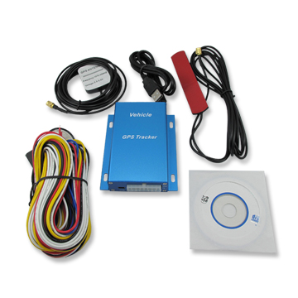
- Show Location Directly on Mobile Phone
- Track by Time Interval
- Track by Distance
- GSM Blind Area Memory
- Internal Memory for Logging
- Inbuilt Motion Sensor for Power Saving
- SOS Panic Button
- Movement Alarm
- Geo-fencing Control
- Low Battery Alarm
- Speeding Alarm
- GPS Blind Area Alarm (in/out)
- Power-cut Alarm
- Engine Cut (Stop Engine)
- I/O: 5 digital inputs (3 negative and 2 positive triggering), 5 outputs and 2 analog inputs of 10 bits resolution

2. For Your Safety

Read these simple guidelines. Not following them may be dangerous or illegal.

Proper Connection | Do not connect any parts of this product to other incompatible devices. When connecting with other devices, read instructions carefully to ensure proper installation.
Qualified Accessories | Use original parts, qualified batteries and peripheral equipments to avoid damage to HS-300V.
Safe Driving | Drivers should not operate this product while driving.
Qualified Service | Only qualified personnel can install or repair HS-300V.
Water Resistance | HS-300V is not water resistant. Keep it dry. Install this device inside the vehicle or use a waterproof bag for protection if necessary.
Confidential Phone Number | For safety reason, do not tell other people the mobile phone number of your HS-300V without taking precautions of security settings.

3. HS-300V Characteristics

Items | Specifications
Power Supply | +9V - +36V / 1.5A
Backup Battery | 850mAh
Normal power consumption | 85mA/h
Dimension | 104mm x 62mm x 24mm
Installation Dimension | 104mm x 83mm x 24mm
Weight | 190g
Operating temperature | -20° to 55° C
Humidity | 5% to 95% Non-condensing
Frequency | Quad Band GSM 850/900/1800/1900Mhz
GPS Module | latest GPS SIRF-Star III chipset
GPS Sensitivity | -159Db
GPS Frequency | L1, 1575.42 MHz
C/A Code | 1.023 MHz chip rate
Channels | 20 channel all-in-view tracking
Position Accuracy | 10 meters, 2D RMS
Velocity Accuracy | 0.1 m/s
Time Accuracy | 1 us synchronized to GPS time
Default datum | WGS-84
Reacquisition | 0.1 sec., average
Hot start | 1 sec., average
Warm start | 38 sec., average
Cold start | 42 sec., average
Altitude Limit | 18,000 meters (60,000 feet) max
Velocity Limit | 515 meters/second (1000 knots) max
LED | 2 LED lights to show GPS/GSM status
Flash Memory | 4MB
Button | One SOS Button
Interface | 5 digital inputs (3 negative and 2 positive triggering)  2 analog inputs  5 outputs.

4. Getting Started

This section will describe how to set up your HS-300V.

4.1 Hardware and Accessories
HS-300V is supplied in a box which includes:
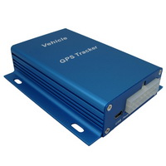 | 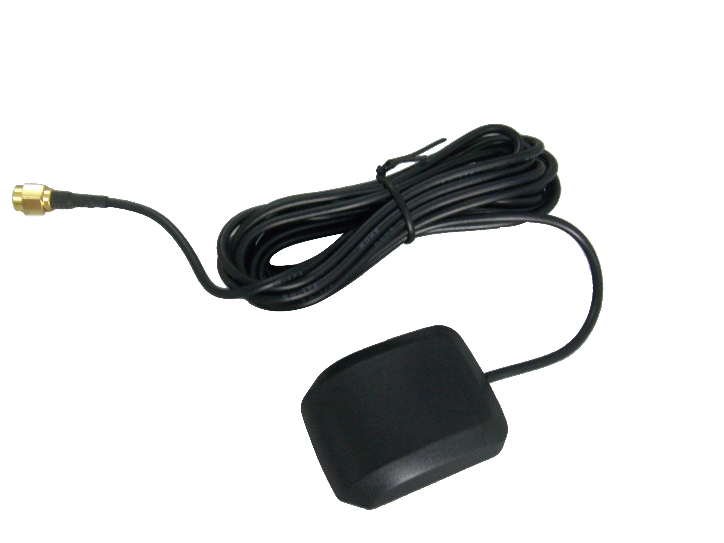 | 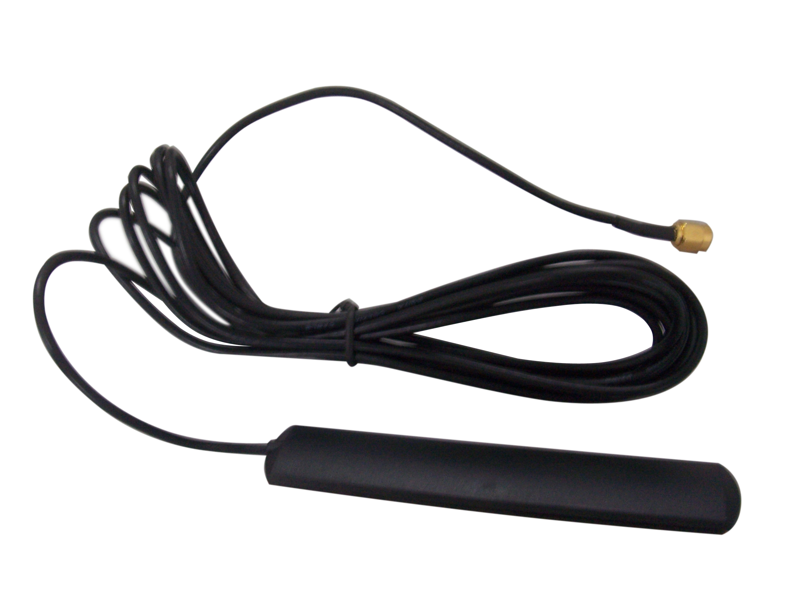 | 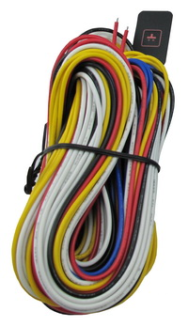 | 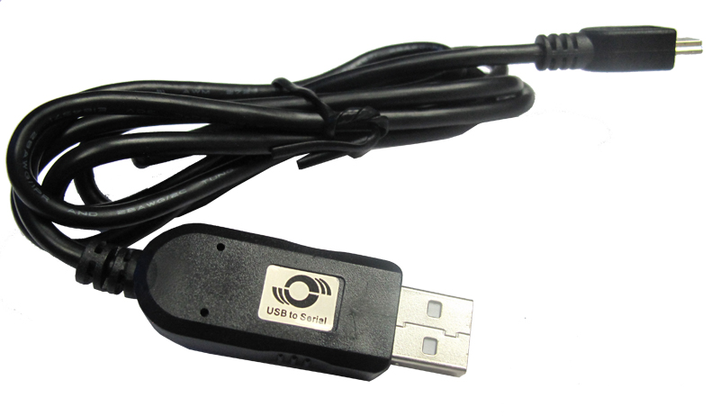 | 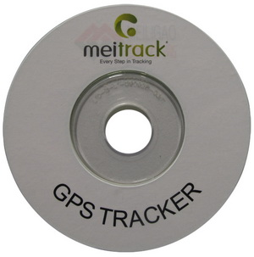
HS-300V with Battery | GPS Antenna | GSM Antenna | Wires with SOS Button | USB Cable | CD

4.2 View
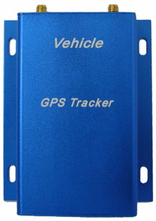 | 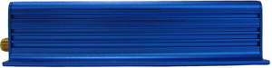  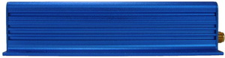 | 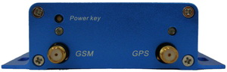  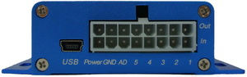 | 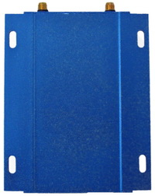
Front View | Side View |  | Back View

4.3 Functional Parts

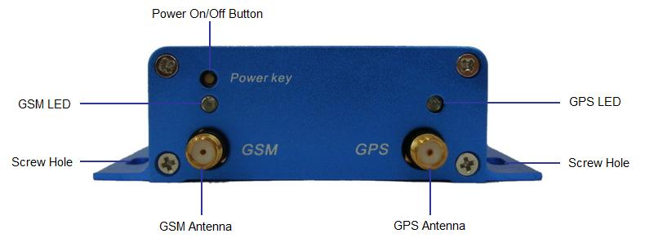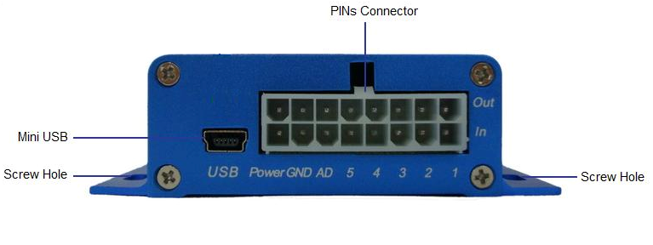
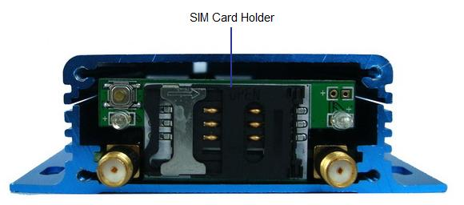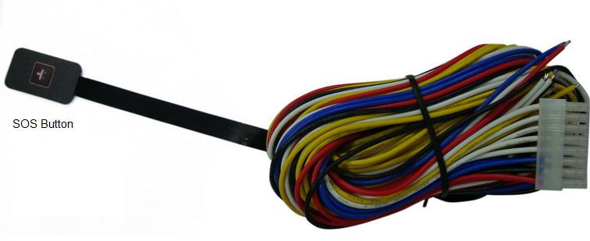

GPS LED (Blue)
On |  |  | One button is pressed or input is active
Flashing ( every 0.1 second) |  |  | The unit is being initialized
Flashing (0.1 second on and 2.9 seconds off) |  |  | HS-300V has a GPS fix
Flashing (1 second on and 2 seconds off) |  |  | HS-300V has no GPS fix
GSM LED (Green)
On |  |  | A call is coming in / a call is being made
Flashing ( every 0.1 second) |  |  | The unit is being initialized
Flashing (0.1 second on and 2.9 seconds off) |  |  | HS-300V is connected to the GSM network
Flashing (1 second on and 2 seconds off) |  |  | HS-300V is not connected to the GSM network
Power On/Off Button |  |  | Press and hold for 3~5 seconds to turn on/off HS-300V
SOS Button |  |  | SOS button is connected with the wires. Press it to send SOS alarm to the preauthorized phone number.
Mini USB |  |  | Used for firmware update, configuration on PC and exporting stored data. (USB-to-Serial Adaptor is required for firmware update, configuration and exporting stored data)
SIM Card Holder |  |  | Insert SIM card here
GSM Antenna |  |  | Connector for GSM antenna
GPS Antenna |  |  | Connector for GPS antenna
Screw Holes |  |  | There are 4 screw holes on the tracker, 2 along either side that act as fixing points to the vehicle
Microphone (optional) |  |  | A microphone to be linked out for listening to the cabin (wiretapping)
PINs Connector
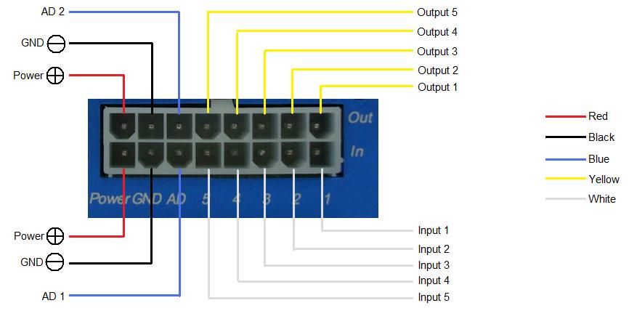
PIN | Color | Function
Power | Red | DC In (power input). Input voltage: 9V~36V. 12V suggested
GND | Black | Ground
In | White | Digital Inputs. In1, In2 and In3 are negative triggering; In4 and In5 are positive triggering
Out | Yellow | Outputs. Low voltage (0V) when effective and open drain when ineffective  Output open drain sink voltage (ineffective): 45V max.  Output low voltage sink current (effective): 500mA max.
AD | Blue | 10 Bits Resolution Analog Inputs. Input voltage: 0~6V
DC Characteristics of PINs
PIN |  | Inactive |  | Active | Maximum
Input 1/2/3 |  | Open drain or >1V |  | 0V(GND) | 45V
Input 4/5 |  | Open drain or 0V(GND) |  | >3V | 45V
Output 1/2/3/4/5 |  | Open drain |  | 0V (GND) | 45V/500mA
DC IN |  | / |  | 9-36V | 45V
AD 1/2 |  | / |  | 0-6V | 45V

4.4 Connecting and Installation
Read this manual before using your HS-300V. Check to make sure all parts are included in the packaging box.
4.4.1 Ensure that your HS-300V has a working SIM card installed.  - Check that the SIM card has not run out of credit (test the SIM card in a phone to make sure it can send and receive SMS)  - Check that the SIM card lock code is turned off  - If you require the function of sending an SMS location report to the authorized phone number when it makes a call to the HS-300V, please make sure the SIM installed supports displaying caller ID. | 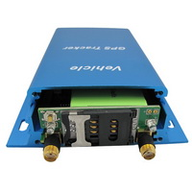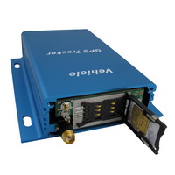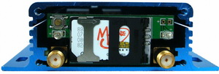
Before inserting SIM card, cut off the power for HS-300V.
Install SIM Card
- Unscrew and remove the front cover of HS-300V.
- Insert the SIM card by sliding it into the card slot with the chip module facing the connectors on PCB.
- Replace the front cover and screw it in.
4.4.2 Antenna Connection  Connect the GSM Antenna to HS-300V.  Connect the GPS Antenna to HS-300V.  - GPS antenna is used to receive satellite signals in the sky. It should be fixed to face the sky, (It is recommended to place this device under the windshield) and should not be covered or shielded by any objects containing metal. | 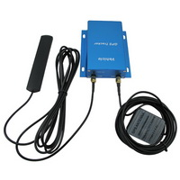
4.4.3 Find a suitable place inside the car for installing HS-300V. Wiring connections must be firm and reliable. The joints should be wrapped tightly with insulating tape. The unused electrical wire should be properly insulated.  Check to make sure all wirings have been connected correctly. Then connect the AVL unit to the motor power. | 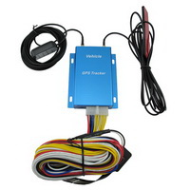
Make a missed phone call the HS-300V using a mobile phone to check if the call can go through. The HS-300V should reply with an SMS indicating longitude, latitude, speed and date. | 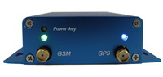

5. Change Password

Command: W******,001,######
Description: Change user’s password.
Note:
1. ****** is user’s password and the default password is 000000. The tracker will only accept commands from a user with the correct password. Commands with wrong password will be ignored.
2. ###### is the new password. Password should be 6 digits.
Example:
W000000,001,123456
W123456,001,999999

6. Time Zone

Command: W******,032,T
Description: Correct time to your local time
Note:
1. Default time of the tracker is GMT
2. This correction is applied to location reports by SMS and SMS alarms.
T=0, to turn off this function;
T=_[-32768,32767] to set time difference in minutes to GMT.

For those ahead of GMT, input the time difference in minutes directly.
For example, for GMT+8, W000000,032,480. (8 Hours is 480 minutes)

‘-‘is required for those behind GMT.
For example, W000000,032,-120. (2 hours or 120 minutes behind GMT)
Example:
W000000,032,480
W000000,032,-120

7. Track

7.1 Track by SMS
- Track on Demand - Reply with longitude, latitude, speed and date
Command: W******,000
Description: To get the current location of the tracker, send this command as an SMS or make a telephone call directly to the tracker. After doing so, the device will report its longitude and latitude by SMS with the format as follows:
Example:Latitude = 22.551668E Longitude = 114.067741N Speed = 0.00 14/07/01 13:37 F:4.1V:13.9V,07,ACC:oN

W000000,000

- Track on Demand - Reply with a link to Google Maps
Command: W******,100
Description: Send this command to the tracker and you will receive an SMS with an http link. Click on the link and the location will be shown directly on your mobile phone using Google maps. For example:
http://maps.google.com/maps?f=q&hl=en&q=22.540103,114.082329&ie=UTF8&z=16&iwloc=addr&om=1
Note: Only smart phones and PDAs support this function.
Example:
W000000,100
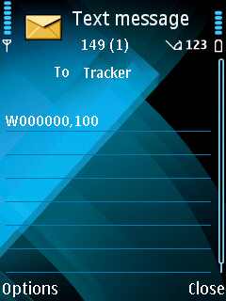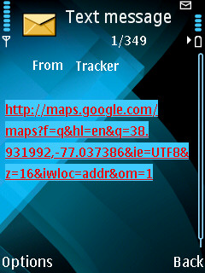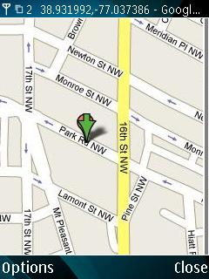

7.2 Track by Calling
Make a missed call to the tracker and it will report its longitude and latitude by SMS with the following format:Latitude = 22.551668E Longitude = 114.067741N Speed = 0.00 14/07/01 13:37 F:4.1V:13.9V,07,ACC:oN

7.3 Track by Preset Interval
Command: W******,002,XXX
Description: Set an interval for the tracker to continuously report its location by SMS
Note:
1. XXX is the interval in minutes;
2. XXX=000 to turn off tracking by time.
Example:
W000000,002,030
The tracker will send location data back to your mobile phone every 30 minutes.

7.4 Google Earth and Google Map
Download Google Earth from http://earth.google.com/.
Start Google Earth (For more information about Google Earth please refer to http://earth.google.com/ or go to http://maps.google.com)
Input the latitude and longitude that you received from the tracker by SMS and click the search button. Google Earth or Google Maps will display the location for you.
Example:
When you receive: Latitude = 22 32 40.05N Longitude = 114 04 57.74E
Type as the following picture shows:
(Note: you should input the latitude and longitude as: 22 32 40.05N 114 04 57.74E)
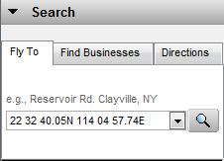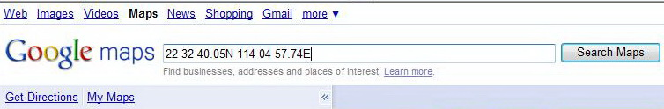
And then you can find the location of your tracker:
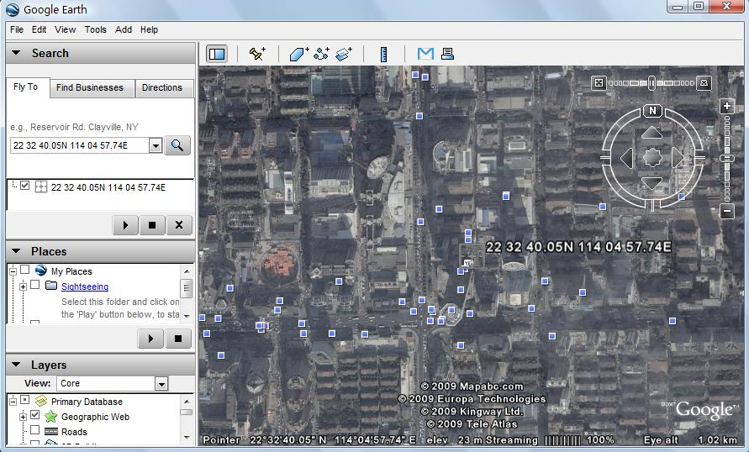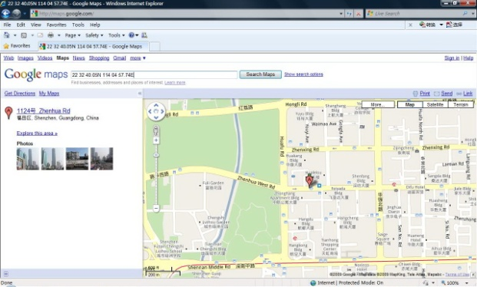
You can also use local map software on PDA or car navigation device to input the coordinates.

7.6 Track by GPRS (o Protocol) between Server and Tracker

7.6.1 Set Tracker’s GPRS ID
Command: W******,010,ID
Description: Set a digital GPRS ID for the tracker.
Note: GPRS ID must not be over 14 digits.
Example:
W000000,010,00001

7.6.2 Set APN
Command: W******,011,APN,Username,Password
Description: Set APN details for the tracker
Note:
1. APN username and password are optional. If no APN username and password are required, just input APN only;
2. APN defaulted as ‘CMNET’;
3. APN + username + password should not over 39 characters.
Example:
W000000,011,CMNET,o,6688
W000000,011,CMNET

7.6.3 Set IP and Port
Command: W******,012,IP,Port
Description: Set the IP and Port of tracker for GPRS communication.
Note:
1. IP is your server’s IP or the domain name.
2. Port: [1,65534]
Example:
W000000,012, 220.121.7.89,8500
W000000,012,www.o.net,8500
SMS query machine settings of the IP port
SMS commands to w*******, 701

7.6.4 Set DNS Server IP (optional)
Command: W******,009,DNS Server IP
Description: If the domain name you set by the last command (W******,012,IP, Port) doesn’t work, your server IP is not properly set. You can first use this command to set DNS Server IP (please check with your DNS server provider for the DNS Server IP) and then redo the command W******,012,IP, Port.
Example: W000000,009,220.23.4.90

7.6.5 Enable GPRS Tracking
Command: W******, 013, X
Description: Enable GPRS tracking function.
Note:
X=0, to turn off GPRS tracking (default);
X=1, to enable GPRS tracking via TCP;
X=2, to enable GPRS tracking via UDP.
Example: W000000,013,1

7.6.6 Set GPRS Interval
Command: W******,014,XXXXX
Description: Set time interval for sending GPRS packets.
Note:
XXXXX should be in five digits and in unit of 10 seconds.
XXXXX=00000, to turn off this function;
XXXXX=00001~65535, time interval for sending GPRS packet and in unit of 10 seconds.
Example: W000000,014,00060
GPRS ACC closing time interval flow setting default upload time, the default value is 3 minutes.
W000000,114, XXXXX
XXXXX=00001~65535, upload time interval (in seconds as a unit)

For more information regarding GPRS tracking please refer to GPRS Communication Protocol.

7.7 Track by GpsGate
The GT30i supports GpsGate Software.
Please contact our company or GpsGate for more information for settings.

8. Authorization

Command: W******,003,F,P,T
Description: Authorize phone numbers for the SOS/inputs, receiving location reports, SMS alarms or phone calls
Note:
F=0, to turn off this function; (default)
F=1, only sends SMS to the authorized phone number;
F=2, only calls the authorized phone number;
F=3, both SMS and calling.
(Note: HS-300V doesn’t support two-way conversation. Calling only gives ring and reminder to the authorized phone.)
P=1, set an authorized number for SOS button (Input 1);
P=2, set an authorized number for Input 2;
P=3, set an authorized number for Input 3.
T: Preset phone number. Max.16 digits.
Example:
W000000,003,1,1,88888888

9. Application Examples for Inputs

9.1 SOS Button Connection
Connect the SOS button and wires as below picture shows:
Input 1 or Input 2 or Input 3
White
SOS Button
Note: input voltage to Input must not over 45V
After above authorization is completed, once the SOS is pressed, an SOS SMS - “SOS Alarm” will be sent to the preauthorized phone number. Then a message with longitude and latitude will follow.
(Note: An SOS button is already connected to HS-300V in standard packing)

9.2 Detecting Lock Status of Car’s Door or Trunk (Car Boot).
Lock Controller
lock
unlock
Input 1 or Input 2 or Input 3
White
Lock Switch
Power supply
When the lock is opened, there will be a negative trigger to Input 1 or Input 2 or Input 3. After this, an SMS alarm will be sent to the authorized phone number, or a GPRS alarm will be sent to the server (please refer to the GPRS Command 0x9999 in GPRS Communication Protocol).

9.3 Connecting with Switch Sensors
The SMS alarm will be sent to the authorized phone number.
White
Switch Sensor
Input 1 or Input 2 or Input 3
9.4 Ignition DetectionThe detection engine state W******, 700, A A=0 A=1 ACC ACC detection functiondetection function (the default off)
ACC must be connected to input 5
Input 4 or Input 5 (positive triggering) can be used for ignition detection. The detection alarm will be sent to the server via GPRS. Please refer to <GPRS Communication Protocol> Alarm Command 0x9999 for more information.
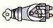
Ignition Switch
Input 4 or Input 5
Battery
Power for ignition

9.5 Analog Input (AD1 and AD2)
Input voltage should be 0~6V. Please refer to GPRS Communication Protocol for more information for AD1 and AD2 data.
For example:
094506.000,A,2232.5412,N,11404.6919,E,0.00,,290709,,*12|1.7|110|0000|00AA,0267
AD1 is 0x00AA and AD2 is 0x0267.
Voltage Formula: Input Voltage=(AD*6)/1024
0x00AA=>170(decimal)=>(170*6)/1024=0.99609375V(voltage)
0x0267=>615(decimal)=>(615*6)/1024=3.603515625V(voltage)

Application Example - Fuel Level Sensor
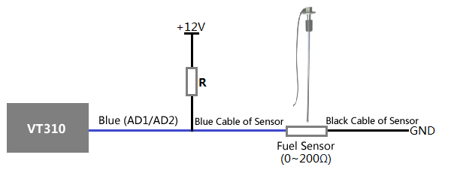
Fuel level sensors supplied by us are resistance-type sensors with output resistance: 0-200Ω(ohm).
For the circuit shown on the right picture, if VCC is 12V, R should be 200Ω(ohm) and if VCC is 24V then R should be 600Ω(ohm) to make the input range to AD1 or AD2 is 0-6V.
The below formula is for calculating the fuel percentage left for this fuel level sensor:
Percentage Left =
AD value
* 100%
1024*2 – AD value
Note: The value must be converted into decimal, for example, 0x0267 is 615 in decimal.

10. Speeding Alarm

Command: W******,005,XX
Description: Turn on speeding alarm. When the tracker speeds higher than the preset value, it will send an SMS alarm to the authorized phone number for SOS.
Note: XX is the preset value of speed and in 2 digits.
=00 , to turn off this function;
=[01, 20] (unit: 10Km/h).
Example: W000000,005,08
When the tracker’s speed is over 80km/h, an SMS alarm will be sent out.

11. Movement/Geo-fence

11.1 Movement Alarm
Command: W******,006,X
Description: When the tracker moves out of a preset circle scope, it will send an SMS alarm to the authorized phone number for SOS.
Note:
1. X is the preset radii to the tracker’s original place.
=0, to turn off this function.
=1, 30m | =2, 50m | =3, 100m | =4, 200m
=5, 300m | =6, 500m | =7, 1000m | =8, 2000m
2. Radii: [1, 4294967295] meter(s), suggest to be set above 100 meters.
3. GPRS command is 0x12.
Example: W000000,006,1
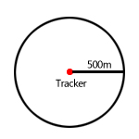
When tracker moves out of this circle scope, it will send out an SMS alarm.

11.2 Geo-fence Alarm
Command: W******,302,X
Description: Turns on Geo-fencing alarm. When the tracker moves in/out the preset scope, it will send an SMS alarm to the authorized phone number for SOS.
Note:
1. X is the parameters which include: latitude, longitude, radii, in, out.
2. Latitude and longitude should be in ASCII format as follows:
Latitude is ddd.dddddd, ‘0’ is needed to be stuffed if no value available. ‘-’ should be added for south.
Longitude is dd.dddddd, ‘0’ is needed to be stuffed if no value available. ‘-’ should be added for west.
3. Radii: [1, 4294967295] meter(s), suggested to be set above 100 meters, if set above 8, it is corresponding radii.
4. If In and Out are 0, corresponding function is invalid. If In and Out are 1, valid.
5. Reply as Geo-Fence Alarm.
6. GPRS exiting command is 0x12, entering command is 0x13.
7. Send W******, 302 to turn off Geo-fence function.
Example:
W000000,302,22.000000,-114.123456,3000,1,1
Remarks:
1. Only one alarm can be set in either In or Out;
2. Only one alarm can be set in either Movement Alarm or Geo-fence Alarm.

12. Track by Distance
Command: W******,303,X
Description: Send this command to set distance interval
Note:
- X= [1, 4294967295], suggested to be set above 300 meters;
- X=0, turn off.
Example: W000000,303,1000

13. Listening-in (Optional)
Command: W******,030,T
Description: Authorize a phone number to make a silent call to the tracker. The tracker will answer the call automatically and allows the caller to listen to what is happening around the tracker. There is no sound when the tracker is working.
Note:
- T is phone number, Max. 16 digits;
- If incoming call is not from authorized phone number, it will be treated as a normal call and would not enter Listening-in status.
Example: W000000,030,138000000

14. Set Sensitivity of Tremble Sensor
Command: W******,035,XX
Description: Send this command to set sensitivity of tremble sensor
Note:
- XX=[1,255], it will be more sensitive if XX is smaller.
- Default value is 30.
Example: W000000,035,30

15. Output Control

15.1 Output Control (Immediate)
Command: W******,020,P,F
Description: Send this command to control the Output of HS-300V
Note:
P=1, Output1;
P=2, Output2;
P=3, Output3;
P=4, Output4;
P=5, Output5.
F=0, to close the output (open drain);
F=1, to open the output (low voltage).
Example: W000000,020,1,1

15.2 Output Control (Conditional)
Command: W******,120,ABCDE or W******,220,ABCDE
Description: Send this command to control the Output of HS-300V. This command is only workable when the speed is below 10km/h(command 120) or 20km/h(command 220) and GPS is available.
Note:
ABCDE represents Out1, Out2, Out3, Out4, and Out5 respectively.
If A or B or C or D or E,
=0, to close the output (open drain);
=1, to open the output (low voltage);
=2, to remain previous status.
Example:
W000000,120,10000
W000000,220,10000

15.3 Application Examples for Outputs

15.3.1 Engine Cut
Relay Connection: Connect a relay as below picture shows:
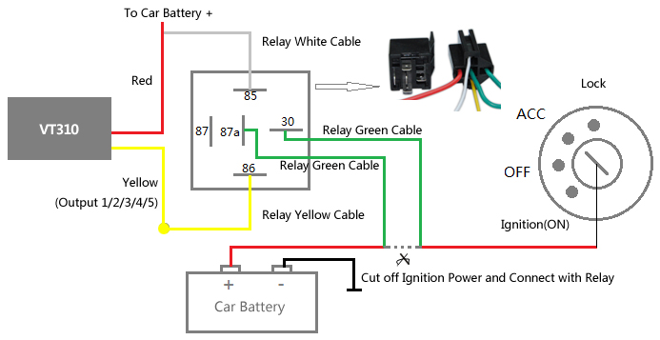

Calculate the correct VCC value according to relay’s parameter to comply with the following requirements:
Output open drain sink voltage (ineffective) | 45V max
Output Low voltage sink current (effective) | 500mA max
Normally two green wires are connected solidly (P1 and P2 are Normal Close[NC] in the relay), when output is open (Output be low voltage), two green wires will disconnect, the engine is then cut.
Take Output1 as an example:
W000000,020,1,1 (cut engine)
W000000,020,1,0 (cancel engine-cut)

15.3.2 Connecting with Car Alarm
When the Output that connected to the car alarm is open, the alarm will start to work.
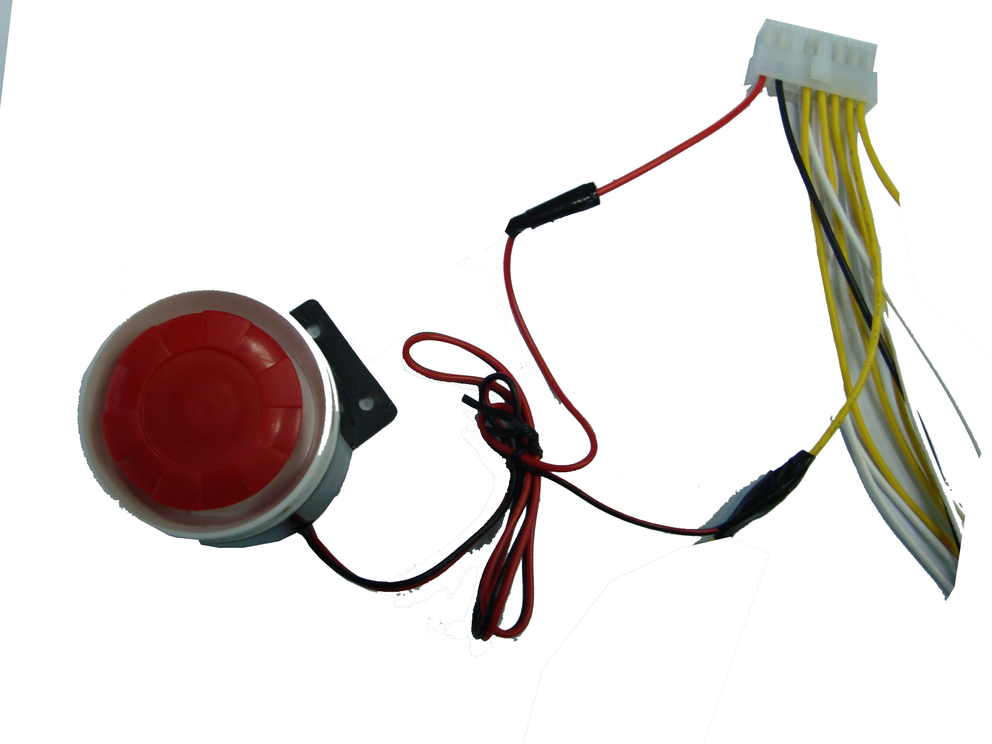
Output 2 or Output 3 or Output 4 or Output5
Alarm

16. Heading Change Report

Command: W******,036,degree
Description: When the heading direction of the tracker changes over the preset degree, a message with location data will be sent back to the server by GPRS. This enhances the accuracy when the tracker makes a direction change.
Note:
degree=0, to turn off this function;
degree=[1,360], to set degree of direction change.
Example: W000000,036,90
When the tracker turns more than 90 degree, a message will be sent back to the server.

17. Heartbeat

Command: W******,015,data
Description: Set an interval for heartbeat.
Note:
data is the interval unit of minutes.
data=0, to turn off this function;
data=1~65535, set interval for heartbeat.
Example:
W000000,015,10
In this example, the tracker will send heartbeat every 10 minutes.

18. Track Log

18.1 Log by Interval
Command: W******,031,X
Description Set time interval for logging GPS information. Log information is stored within the device memory. When the memory gets full, the newest record will be overwritten on top of the oldest (FIFO - First In, First Out). In this case, only the newest information is stored.
Note:
1. X=0, to turn off this function. X=[1, 65535] to set interval in the unit of SECOND.
2. The logged message is in GPRMC format and includes:
Date and time
Longitude
Latitude
Speed
Direction
3. All data, stored within the memory, may be exported to the PC using the USB connector. To do this, the “GPSLog” program has to be used (please refer to GPSLog User Guide and GPRS Communication Protocol for more information).
4. The device has 4MB of internal memory space for storing the track log. The Device is able to store up to 180,000 records within the memory.
Example:
W000000,031,60
The tracker will store GPS data every 60 seconds.

18.2 Auto Log when no GPRS
When there is no GPRS connection, the tracker can store all GPS information triggered by preset tracking interval, alarms, request, or button activation and send this information (FIFO - First In, First Out) to server by GPRS or preauthorized mobile phone by SMS when GPRS connection recovers.
The interval memory can store up to 1500 SMS and 4600 GPRS message.

18.3 Format Buffer
Command: W******, 703
Description: This command clears the data stored in the buffer.
Note: Deleted data can no longer be recovered
Example: W000000,703

19. Power Down

Command: W******,026,XX
Description: This command puts the tracker in power down mode when it is inactive or immobile for a period of time. In Power Down mode, GPS stops working, GSM enters sleep mode and stops sending out messages. The device remains in this mode until it is activated by message, incoming calls, movement, or triggered by the button.
Note:
XX=00, to turn off this function;
XX=01~99, to turn on Power Down after a specified period of being inactive (or stationary). It is in unit of minute.
Example: W000000,026,10
The tracker will enter power down mode after it is inactive (or stationary) for 10 minutes.

20. Get IMEI

Command: W******,601
Description: Get IMEI of the tracker. IMEI is 15 digits
Example: W000000,601

21. Initialization

Command: W******,990,099###
Description: This sets all settings (except for the password) back to factory default.
Note: Send SMS “Default?” to the device. Within 120 seconds, send this SMS command to the tracker.
### is the ending character and is required in the text message.
Example: W000000,990,099###

22. Password Initialization

Command: W888888,999,666
Description: This resets the password back to factory default and can be used in case you forget your password.
Note: Send SMS “Default?” to the device, and then, within 120 seconds, send this SMS command to the tracker to set the password back to factory default (000000).
If you have set an authorized telephone number, when the password has been successfully preset, the telephone will receive W888888,999,666
Example: W888888,999,666

For more details regarding SMS commands, please go to Annex 1 Command List

23. Parameter Editor

The tracker can also be configured by computer using the Parameter Editor. This method is much easier and user friendly.
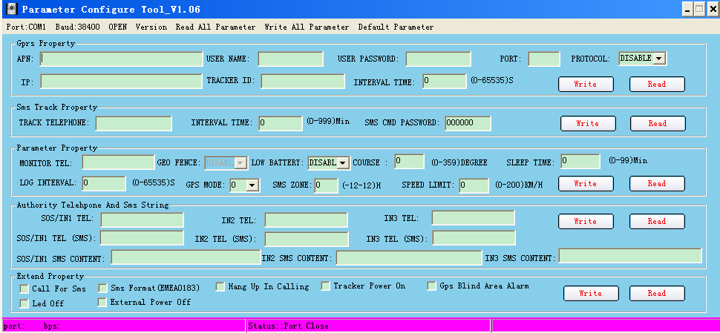
Please refer to GPS Tracker Parameter Editor for more information.

24. Copyright and Disclaimer

©

TAnnex 1. SMS Command List
Note: ****** is user’s password and the default password is 000000. The tracker will only accept commands from a user with the correct password. Commands with wrong password will be ignored.
Description | SMS Command | Example
Track on Demand | W******,000 | W000000,000
Remarks: To get the current location of the tracker, send this command as an SMS or make a telephone call directly to the tracker. After doing so, the device will report its longitude and latitude by SMS with format as follows:
Latitude = 22 32 36.63N Longitude = 114 04 57.37E, Speed = 2.6854Km/h, 2008-12-24,01:50
Track on Demand  -Google Link | W******,100 | W000000,100
Remarks: Send this command to the tracker and you will receive an SMS with a http link. Click on the link and the location can be shown directly on your mobile phone using Google maps. For example:
http://maps.google.com/maps?f=q&hl=en&q=22.540103,114.082329&ie=UTF8&z=16&iwloc=addr&om=1
(Note: Only smart phones and PDAs support this function.)
Change Password | W******,001,###### | W000000,001,123456
Remarks: To change user’s password. ###### is the new password. Password should be 6 digits.
Track by Interval | W******,002,XXX | W000000,002,030
Remarks: To set interval for automatic timed report.
XXX is the interval in minutes. If XXX=000, turn off tracking by time.
In this example, the tracker will send location data back to your mobile phone every 30 minutes.
Authorization | W******,003,F,P,T1  (W******,003,F,P,T1,T2) | W000000,003,3,1,88888888  W000000,003,3,1,88888888,99999999
Remarks: To authorize phone numbers for button/Inputs for receiving location reports, SMS alarms or phone calls.
F=0, to turn off this function; (default)
F=1, only sends SMS to the authorized phone number;
F=2, only calls the authorized phone number;
F=3, both SMS and calling.
P=1, set an authorized number for Input 1;
P=2, set an authorized number for Input 2;
T1: Preset phone number. Max.16 digits.
If you need to set different numbers for receiving SMS and phone call, you can use W******,003,F,P,T1,T2, In this case T1 is the phone number for receiving SMS and T2 for receiving phone calls.
Note: HS-300V doesn’t support two-way conversation. Calling only gives ring and reminder to the authorized phone.
Speeding Alarm | W******,005,XX | W000000,005,08
Remarks: When the tracker speeds higher than the preset value, it will send an SMS to the authorized phone number for SOS.
XX is the preset value of speed and in 2 digits.
=00 , to turn off this function;
=[01, 20] (unit: 10Km/h).
In this example, when the tracker’s speed is over 80km/h, an SMS alarm will be sent out.
Movement Alarm | W******,006,X | W000000,006,6
Remarks: When the tracker moves out of a preset circle scope, it will send an SMS alarm to the authorized phone number for SOS.
X is the preset radii to the tracker’s original place.
=0, to turn off this function
=1, 30m | =2, 50m | =3, 100m | =4, 200m
=5, 300m | =6, 500m | =7, 1000m | =8, 2000m

Geo-fence Alarm | W******,302,X | W000000,302,22.000000,-114.123456,3000,1,1
Remarks: Turn on Geo-fencing alarm. When the tracker moves in/out the preset scope, it will send an SMS alarm to the authorized phone number for SOS.
Note:
1. X is the parameter that includes: latitude, longitude, radii, in, out.
2. Latitude and longitudes should be in ASCII format as follows:
Latitude is ddd.dddddd, ‘0’ is needed to be stuffed if no value available. ‘-’ should be added for south.
Longitude is dd.dddddd, ‘0’ is needed to be stuffed if no value available. ‘-’ should be added for west.
3. Radii: [1, 4294967295] meter(s), suggest to be set above 100 meters, if set above 8, it is corresponding radii.
4. If In and Out are 0, corresponding function is invalid, if are 1, valid.
5. Reply as Geo-Fence Alarm.
6. GPRS exiting command is 0x12, entering command is 0x13.
7. Send W******, 302 to turn off Geo-fence function.
Track by Distance | W******,303,X | W000000,303,1000
Remarks: Send this command to set distance interval
Note:
- X= [1, 4294967295], suggest to be set above 300 meters;
- X=0, turn off.
Extended Functions | W******,008,ABCDEFGHIJ### | W000000,008,1011100011###
Remarks:
A=0, turn off the function of sending SMS location report after a phone call is made to the tracker;
A=1, turn on the function of sending SMS location report after a phone call is made to the tracker.
B=0, location data of NMEA 0183 GPRMC will be interpreted into normal text for easy reading;
For example, Latitude = 22 32 36.63N Longitude = 114 04 57.37E, Speed = 2.6854Km/h, 2008-12-24,01:50
B=1, location data complies with NMEA 0183 GPRMC protocol.
For example, $GPRMC,161509.000,A,2232.5485,N,11404.6887,E,0.3,153.7,290709,,*03
C=0, turn off the function to automatically hang up an incoming call;
C=1, turn on the function to automatically hang up an incoming call after 4 - 5 rings.
D=0, turn off the function of sending an SMS when the tracker is turned on;
D=1, turn on the function of sending an SMS to the authorized phone number for SOS when the tracker is turned on.
E, defaulted as 1 (the tracker shuts down automatically when the power voltage is lower than 3V).
F=0, turn off the SMS alarm when the tracker enters GPS blind area;
F=1, turn on the SMS alarm when the tracker enters GPS blind area. SMS is to be sent to the authorized phone number for SOS.
G=0, all LEDs work normally;
G=1, all LEDs stop flashing when the tracker is working.
H, reserved and defaulted as ‘0’.
I=0, turn off the function of sending SMS alarm when the extra power of the vehicle tracker is cut;
I=1, turn on the function of sending an SMS alarm to the authorized phone number for SOS when the extra power of the vehicle tracker is cut.
J, defaulted as 1.
### is the ending character.
(ABCDEFGHIJ defaulted as 1000100001)
Presetting by SMS for GPRS tracking (Ensure that your SIM card supports GPRS connection prior to setting)
Set Tracker’s GPRS ID | W******,010,ID | W000000,010,00001
Remarks: to set a digital GPRS ID for the tracker.
GPRS ID must not over 14 digits.
Set APN | W******,011,APN,Username,Password | W000000,011,CMNET,o,6688  W000000,011,CMNET
Remarks: If no APN username and password are required, just input APN only.
APN defaulted as ‘CMNET’.
APN + username + password should not over 39 characters.
Set IP and Port | W******,012,IP,Port | W000000,012, 220.121.7.89,8500  W000000,012,www..net,8500
Remarks: IP is your server’s IP or the domain name. Port: [1,65534]
Set DNS Server IP | W******,009,DNS Server IP | W000000,009,220.23.4.90
Remarks: If the domain name you set by the last command (W******,012,IP, Port) doesn’t work, your server IP is not properly set. You can first use this command to set DNS Server IP (please check with your DNS server provider for the DNS Server IP) and then redo the command W******,012,IP,Port.
Enable GPRS Tracking | W******,013,X | W000000,013,1
Remarks:
X=0, to turn off GPRS tracking (default);
X=1, to enable GPRS tracking via TCP;
X=2, to enable GPRS tracking via UDP.
Set GPRS Interval | W******,014,XXXXX | W000000,014,00060
Remarks: to set time interval for sending GPRS packets.
XXXXX should be in five digits and in unit of 10 seconds.
XXXXX=00000, to turn off this function;
XXXXX=00001~65535, time interval for sending GPRS packet and in unit of 10 seconds.
In this example, the tracker will send every 600 seconds (10 minutes).
Set Heartbeat Interval | W******,015,data | W000000,015,10
Remarks: to set interval for heartbeat.
Data: in unit of minute
data=0, to turn off this function;
data=1~65535, set interval for heartbeat.
In this example, the tracker will send heartbeat every 10 minutes.
Set Sensitivity of Tremble Sensor | W******,035,XX | W000000,035,30
Remarks: Send this command to set sensitivity of tremble sensor
Note:
- XX=[1,255], it will be more sensitive if XX is smaller.
- Default value is 30.
Example: W000000,035,30
Heading Change Report | W******,036,degree | W000000,036,90
Remarks: when the heading direction of the tracker changes over the preset degree, a message with location data will be sent back to the server by GPRS.
degree=0, to turn off this function;
degree=[1,360], to set degree of direction change.
For more information regarding GPRS tracking please refer to GPRS Communication Protocol.
Output Control (Immediate) | W******,020,P,F | W000000,020,1,1
Remarks:
P =1, Output1 | =2, Output2 | =3, Output3 | =4, Output4 | =5,Output5

F =0, to close the output (open drain) | =1, to open the output (Low voltage)
For example, if you have connected Output1 with a relay, you can send W000000,020,1,1 to stop the engine.
Output Control (Conditional) | W******,120,ABCDE  W******,220,ABCDE | W000000,120,10000  W000000,220,10000
Remarks: This function is achievable only when the speed is below 10km/h(command 120) or 20km/h(command 220) and meantime GPS is available.
ABCDE represents Out1, Out2, Out3, Out4, and Out5 respectively.
If A or B or C or D or E,
=0, to close the output (open drain) | =1, to open the output (low voltage) | =2, to remain previous status

Sleep Mode | W******,021,X | W000000,021,2
Remarks: this setting is for power saving.
X=0 turn off sleep mode | X=1 Level I | X=2 Level II | X=3 Level III
Here is some explanation for the sleep mode.
GPS module will be closed for 64 seconds * X ( X=1, 2, 3), if it gets continuous GPS fixed for 32 times or Non-GPS fixed for 128 times. After that, GPS module will periodically work and close.
Power Down | W******,026,XX | W000000,026,10
Remarks: power down mode when the tracker is inactive (stationary) for a period of time.
In Power Down mode, GPS stops working and GSM enters sleep and stop sending out message until it is activated by message, incoming calls, movement or input changes.
XX=00, to turn off this function.
XX=01~99, to turn on Power Down after a specified period of being inactive. It is in unit of minute.
In this example, the tracker will enter power down mode after it is inactive for 10 minutes.
Listening-in (Voice Monitoring) | W******,030,T | W000000,030,138000000
Remarks: Authorize a phone number to make a silent call to the tracker. The tracker will answer the call automatically and allows the caller to listen to what happens around the tracker. There is no sound when the tracker is working.
Note:
T is phone number, Max. 16 digits;
If incoming call is not from authorized phone number, it will be treated as a normal call and would not enter Listening-in status.
Set Log Interval | W******,031,X | W000000,031,60
Remarks: to set the interval for storing GPS data into tracker’s flash memory.
(Note: this interval is not relevant to the interval of SMS/GPRS tracking)
X=0, to turn off this function.
X=[1, 65535] to set interval in second.
In this example of W000000,031,60, the tracker will store location data every 60 seconds.
Format Buffer | W******,703 | W000000,703
Remarks: This command clears the data stored in the buffer.
Note: Deleted data can’t recover any more.
Time Zone | W******,032,T | W000000,032,480 W000000,032,-120
Remarks: Default time of the tracker is GMT, you can use this command to correct it to your local time. This command is for SMS tracking only.
T=0, to turn off this function;
T= [-32768,32767] to set time difference in minute to GMT.
For those ahead of GMT, just input the time difference in minute directly. For example, GMT+8, W000000,032,480
‘-‘is required for those behind GMT. For example, W000000,032,-120.
Set SMS Header | W******,033,P,Char | W000000,033,1,help
Remarks: this command is to set initial characters for SOS message when SOS/IN1, Button B/IN2, Button C/IN3 is pressed.
P=1, SOS button/Input1 | P=2, B button/Input2 | P=3, C button/Input3
Char is the character in SOS message and max 32 characters and defaulted as:
1 SOS Alarm! | 2 Cry For Help! | 3 Call The Police!

Get Version No. and Serial No. | W******,600 | W000000,600
Remarks: to get the version and serial number of tracker’s firmware
Get IMEI | W******,601 | W000000,601
Remarks: to get IMEI of the tracker
Reboot GSM | W******,901### | W000000,901###
Remarks: to reboot the GSM module of the tracker
Reboot GPS | W******,902### | W000000,902###
Remarks: to reboot the GPS module of the tracker
Initialization | W******,990,099### | W000000,990,099###
Remarks: Send SMS “Default?” to the device, and then send (within 120 seconds) this SMS command to the tracker to make all settings (except for the password) back to factory default.
### is the ending character.
Password Initialization | W888888,999,666 | W888888,999,666
Remarks: In case you forget your password, Send SMS “Default?” to the device, and then send (within 120 seconds) this SMS command to the tracker to make the password back to factory default (000000).

Annex 2. Troubleshooting

Problem: Unit will not turn on when pushing the power switch to On side
Possible Cause: | Resolution:
Power switch was not pushed properly | Make sure the power button is pushed to On side
Battery needs charging | Recharge battery for 3 hours
Problem: Unit will not reply with SMS
Possible Cause: | Resolution:
Green LED is flashing (1 second on and 2 seconds off) | Make sure HS-300V is connected to GSM network
GSM Network is slow | Some GSM networks slow down during peak time or when they have equipment problems
Unit is sleeping or in power down mode | Cancel sleeping mode or power down
Wrong password in your SMS or wrong SMS format | Write correct password or SMS format
The SIM has run out of credit | Replace or top up the SIM card
Problem: Green LED is Flashing (1 second on and 2 seconds off)
Possible Cause: | Resolution:
No GSM signal | Check with a mobile phone to see if there is a signal in the area or try to call the unit to see if you hear a ring tone
No SIM card | Insert a working SIM card. Check in phone that the SIM can send SMS message
SIM card has expired | Check in phone that the SIM can send SMS message. Replace SIM card if needed
SIM has PIN code set | Remove PIN code by inserting SIM in your phone and deleting the code
SIM is warped or damaged | Inspect SIM, clean the contacts. If re-inserting does not help try another to see if it will work
Roaming not enabled | If you are in a different country your SIM account must have roaming enabled
Battery is low | Recharge the unit and the GSM will start working
Problem: Blue LED is Flashing (1 second on and 2 seconds off) or the SMS received starts with ‘Last…’
Possible Cause: | Resolution:
Unit does not have clear view of the sky | Move the unit to a location where the sky is visible. Tall buildings, trees, and heavy rain can cause problems with the GPS reception.
Bad GPS reception | Place the front side of HS-300V towards sky
Battery is low | Recharge the unit and the GPS will start working.
Problem: Unit Fails to Connect to Server via GPRS
Possible Cause: | Resolution:
SIM card in device does not support GPRS function | Enable SIM card GPRS function
GPRS function of HS-300V is turned off | Turn on GPRS function
Incorrect IP address or PORT | Get the right IP address and PORT and reset
GSM signal is weak | Move the unit to a location with good GSM reception
Problem: Unit will not turn on
Possible Cause: | Resolution:
Wiring was not connected properly | Check and make sure wiring connection is in order
Battery needs charging | Recharge battery
Problem: Unit will not respond to SMS
Possible Cause: | Resolution:
GSM antenna was not installed properly | Make HS-300V connected to GSM network
GSM Network is slow | Some GSM networks slow down during peak time or when they have equipment problems
Unit is sleeping | Cancel sleeping mode
Wrong password in your SMS or wrong SMS format | Write correct password or SMS format
The SIM in HS-300V has run out of credit | Replace or top up the SIM card
No SIM card | Insert a working SIM card. Check in phone that the SIM can send SMS message
SIM card has expired | Check in phone that the SIM can send SMS message. Replace SIM card if needed
SIM has PIN code set | Remove PIN code by inserting SIM in your phone and deleting the code
SIM is warped or damaged | Inspect SIM, clean the contacts. If re-inserting does not help try another to see if it will work
Roaming not enabled | If you are in a different country your SIM account must have roaming enabled
Error connecting GSM antenna | Make sure the GSM antenna is connected to the GSM interface
Problem: SMS received starts with ‘Last…’
Possible Cause: | Resolution:
Unit does not have clear view of the sky | Move the antenna of the unit to a location where the sky is visible
HS-300V is in an inner place | Wait for the target to come out
Battery is low | Recharge the unit and the GPS will start working
Error connecting GPS antenna | Make sure the GPS antenna is connected to the GPS interface
Problem: Unit Fails to Connect to Server via GPRS
Possible Cause: | Resolution:
SIM card in HS-300V does not support GPRS function | Enable SIM card GPRS function
GPRS function of HS-300V is turned off | Turn on GPRS function of HS-300V
Incorrect IP address or PORT | Get the right IP address and PORT and reset to HS-300V
GSM signal is weak | Move the unit to a location with good GSM reception

